# **Practical 02 Study Contents**

# **Types of Keys in Relational Model (Candidate, Super, Primary, Alternate and Foreign)**

Keys are widely used to identify the tuples(rows) uniquely in the table. We also use keys to set up relations amongst various columns and tables of a relational database.

## **Why do we require Keys in a DBMS?**

We require keys in a DBMS to ensure that data is organized, accurate, and easily accessible. Keys help to uniquely identify records in a table, which prevents duplication and ensures data integrity.

Keys also establish relationships between different tables, allowing for efficient querying and management of data. Without keys, it would be difficult to retrieve or update specific records, and the database could become inconsistent or unreliable.

## **Different Types of Database Keys**

### **Super Key**

The set of one or more attributes (columns) that can uniquely identify a tuple (record) is known as Super Key. For Example, STUD_NO, (STUD_NO, STUD_NAME), etc.

A super key is a group of single or multiple keys that uniquely identifies rows in a table. It supports NULL values in rows.

A super key can contain extra attributes that aren’t necessary for uniqueness. For example, if the “STUD_NO” column can uniquely identify a student, adding “SNAME” to it will still form a valid super key, though it’s unnecessary.

**Example:**

**Table STUDENT**

| **STUD_NO** | **SNAME** | **ADDRESS** | **PHONE** |
| --- | --- | --- | --- |
| 1 | Shyam | Delhi | 123456789 |
| 2 | Rakesh | Kolkata | 223365796 |
| 3 | Suraj | Delhi | 175468965 |

Consider the table shown above.

**STUD_NO+PHONE is a super key.**

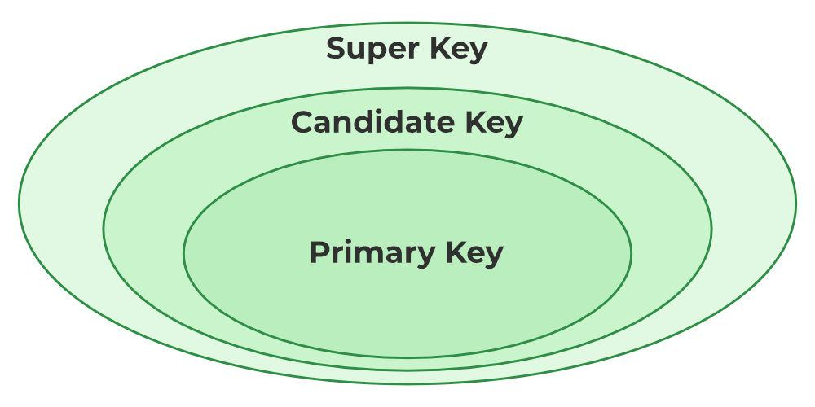

*Relation between Primary Key, Candidate Key, and Super Key*

### **Candidate Key**

The minimal set of attributes that can uniquely identify a tuple is known as a candidate key. For Example, STUD_NO in STUDENT relation.

* A candidate key is a minimal super key, meaning it can uniquely identify a record but contains no extra attributes.
* It is a super key with no repeated data is called a candidate key.
* The minimal set of attributes that can uniquely identify a record.
* A candidate key must contain unique values, ensuring that no two rows have the same value in the candidate key’s columns.
* Every table must have at least a single candidate key.
* A table can have multiple candidate keys but only one primary key.

**Example:**

STUD_NO is the candidate key for relation STUDENT.

**Table STUDENT**

| **STUD_NO** | **SNAME** | **ADDRESS** | **PHONE** |
| --- | --- | --- | --- |
| 1 | Shyam | Delhi | 123456789 |
| 2 | Rakesh | Kolkata | 223365796 |
| 3 | Suraj | Delhi | 175468965 |

* The candidate key can be simple (having only one attribute) or composite as well.

**Example:**

{STUD_NO, COURSE_NO} is a composite

candidate key for relation STUDENT_COURSE.

**Table STUDENT_COURSE**

| **STUD_NO** | **TEACHER_NO** | **COURSE_NO** |
| --- | --- | --- |
| 1 | 001 | C001 |
| 2 | 056 | C005 |

### **Primary Key**

There can be more than one candidate key in relation out of which one can be chosen as the primary key. For Example, STUD_NO, as well as STUD_PHONE, are candidate keys for relation STUDENT but STUD_NO can be chosen as the primary key (only one out of many candidate keys).

* A primary key is a unique key, meaning it can uniquely identify each record (tuple) in a table.
* It must have unique values and cannot contain any duplicate values.
* A primary key cannot be NULL, as it needs to provide a valid, unique identifier for every record.
* A primary key does not have to consist of a single column. In some cases, a composite primary key (made of multiple columns) can be used to uniquely identify records in a table.
* Databases typically store rows ordered in memory according to primary key for fast access of records using primary key.

**Example:**

STUDENT table -> Student(STUD_NO, SNAME, ADDRESS, PHONE) , STUD_NO is a primary key

**Table STUDENT**

| **STUD_NO** | **SNAME** | **ADDRESS** | **PHONE** |
| --- | --- | --- | --- |
| 1 | Shyam | Delhi | 123456789 |
| 2 | Rakesh | Kolkata | 223365796 |
| 3 | Suraj | Delhi | 175468965 |

### 

### **Alternate Key**

An **alternate key** is any candidate key in a table that is **not** chosen as the **primary key**. In other words, all the keys that are not selected as the primary key are considered alternate keys.

* An alternate key is also referred to as a **secondary key** because it can uniquely identify records in a table, just like the primary key.
* An alternate key can consist of **one or more columns** (fields) that can uniquely identify a record, but it is not the primary key
* Eg:- SNAME, and ADDRESS is Alternate keys

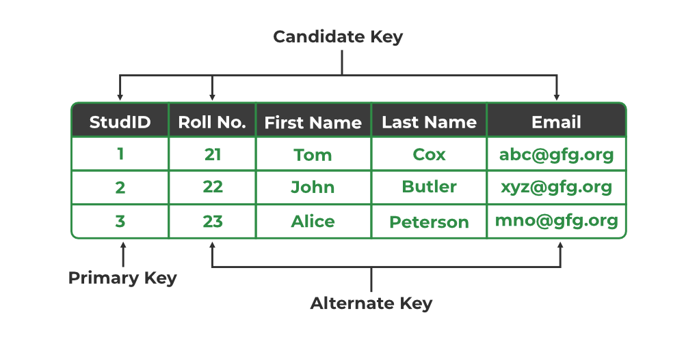

*Primary Key, Candidate Key, and Alternate Key*

### **Foreign Key**

A **foreign key** is an attribute in one table that refers to the **primary key** in another table. The table that contains the foreign key is called the **referencing table**, and the table that is referenced is called the **referenced table**.

* A **foreign key** in one table points to the **primary key** in another table, establishing a relationship between them.
* It helps **connect two or more tables**, enabling you to create relationships between them. This is essential for maintaining data integrity and preventing data redundancy.
* They act as a cross-reference between the tables.
* **For example, DNO is a primary key in the DEPT table and a non-key in EMP**

It may be worth noting that, unlike the Primary Key of any given relation, Foreign Key can be NULL as well as may contain duplicate tuples i.e. it need not follow uniqueness constraint. For Example, STUD_NO in the STUDENT_COURSE relation is not unique. It has been repeated for the first and third tuples. However, the STUD_NO in STUDENT relation is a primary key and it needs to be always unique, and it cannot be null.

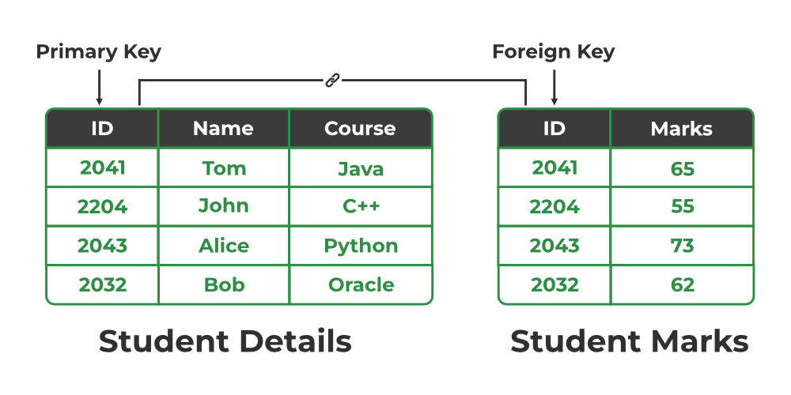

*Relation between Primary Key and Foreign Key*

### **Composite Key**

Sometimes, a table might not have a single column/attribute that uniquely identifies all the records of a table. To uniquely identify rows of a table, a combination of two or more columns/attributes can be used. It still can give duplicate values in rare cases. So, we need to find the optimal set of attributes that can uniquely identify rows in a table.

* It acts as a primary key if there is no primary key in a table
* Two or more attributes are used together to make a composite key .
* Different combinations of attributes may give different accuracy in terms of identifying the rows uniquely.

**Example:**

**FULLNAME + DOB can be combined**

**together to access the details of a student.**

